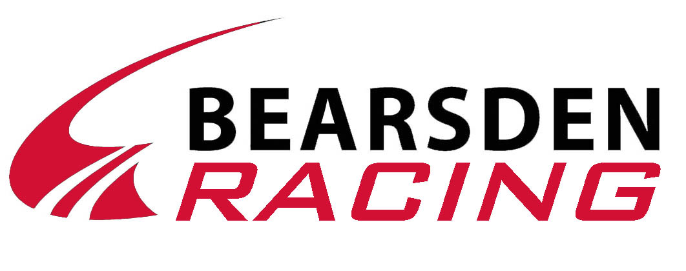

Bearsden Ski Club Dry Slope Championships 2019

Sunday 8th December

Warm up - 1.00pm
Course Inspection 1.30pm - 2pm
Race Starts - 2pm

Open to all Club Members

Categories

Junior

Mini’s 2014 and younger

Bairns Born 2009-2013
Children I Born 2007-2008
Children II Born 2005-2006

Intermediate
Junior Born 2002- 2004

Senior
Senior Born 2001 or earlier
Veteran Born 1979 or earlier
Instructor Any club instructor

Family A relay team of four, which must include three members from the same family one off them being a parent. One guest, also a Member is allowed.

Individual Championship – Race Format
Two timed runs over a special course with the best to count.
Racers will not be allowed to practice the course.

Family Race – Race Format
Dual slalom, knockout relay race.

A one off entry fee of £5 per person covers all races.
RACE TRAINEES DO NOT PAY
All race trainees have free entry into this race.

CLOSING DATE
The entry forms and fee should be returned to the club by
Thursday 5th December 2019

Bearsden Ski Club Dry Slope Championships 2019

Entry Form for individuals and families

Name ___________________________________________

Address___________________________________________________

__________________________________________________________

__________________________________________________________

Telephone Number ___________________________

Racers

Name DOB Age Sex Category

___________________________________________________________

___________________________________________________________

___________________________________________________________

___________________________________________________________

___________________________________________________________
If entering as an individual, without a family, fill in your name and address at the top and in the first line of the racers section.
If entering as a family put family name at top then individual entries in racers section.

There will be a presentation of medals in the clubhouse after the racing has finished.
I hereby free and relieve Bearsden Ski Club, its officials, members, employees and voluntary helpers of any liability for injury, loss or damage of any kind sustained by me whether due to gross negligence or otherwise. For racers less than 18 years of age a parent or responsible adult must sign.

______________________________________________________ Date__________

I enclose entry fee of £5.00 per individual entry.

Entries should be returned to the club with payment by Thursday 5th December 2019

